1. How to create table?

1. How check object type of a table?

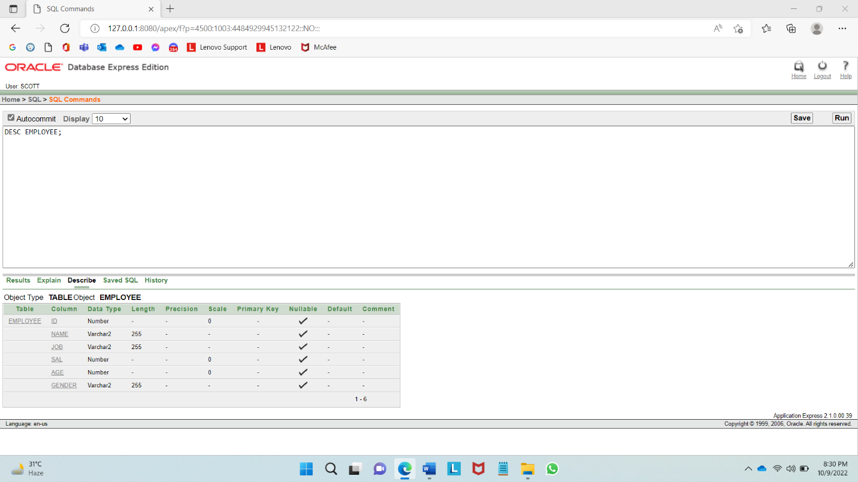

1. How to insert values into a table?

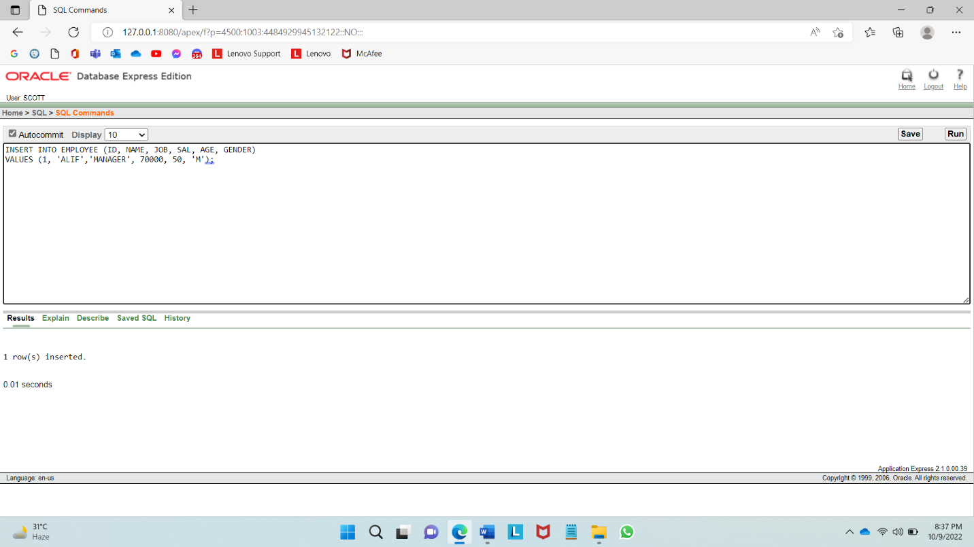

1. How to select all column from a table?

1. How to select only one column from a table?

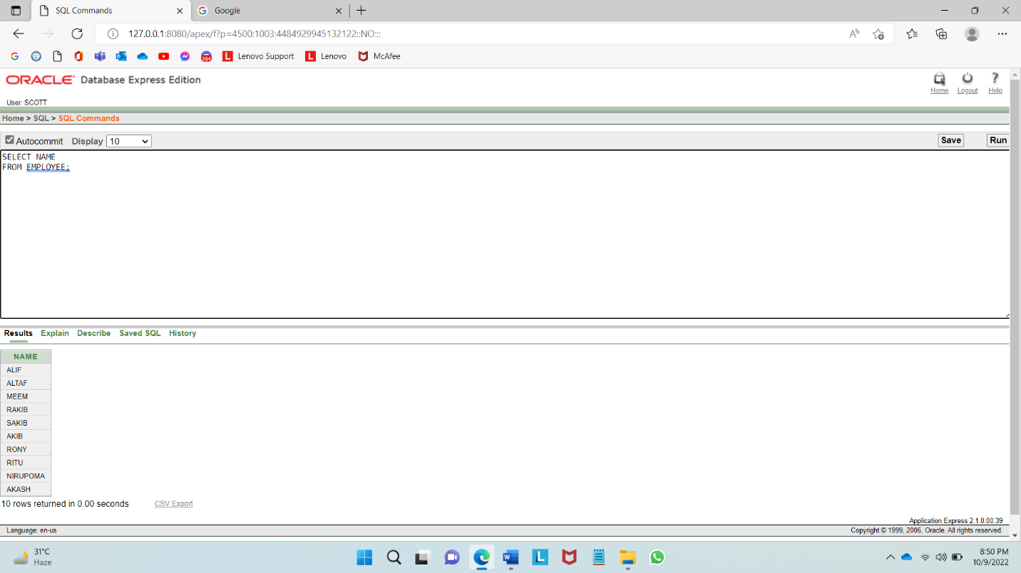

1. How to select Specific column from a table?

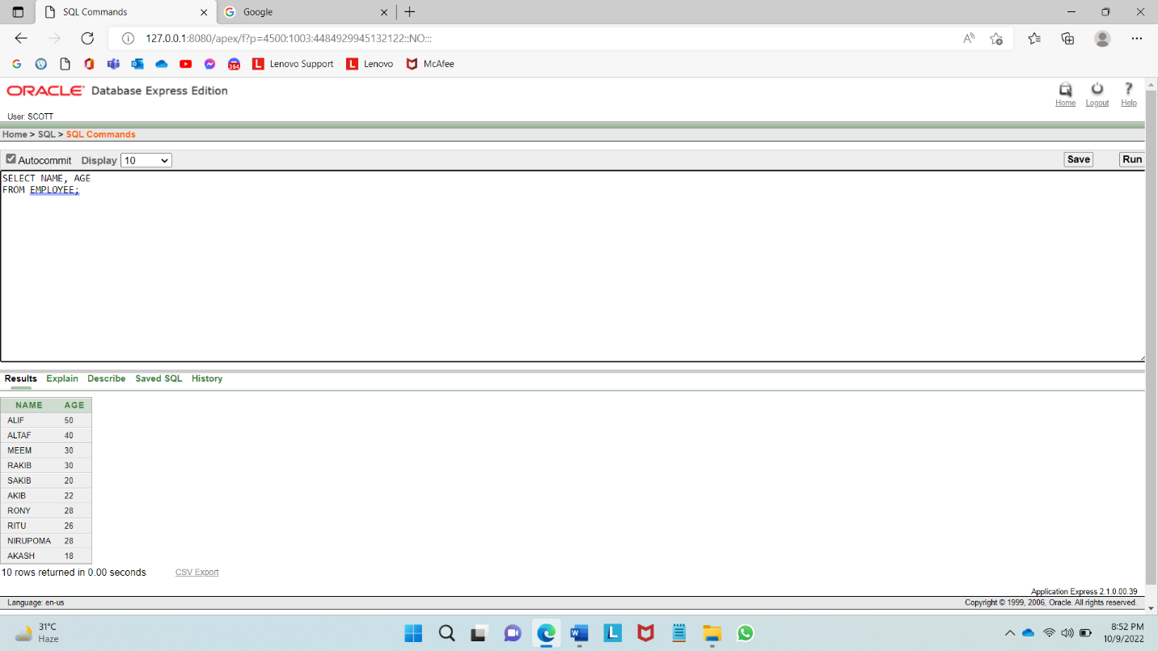

1. How to use arithmetic operator ?

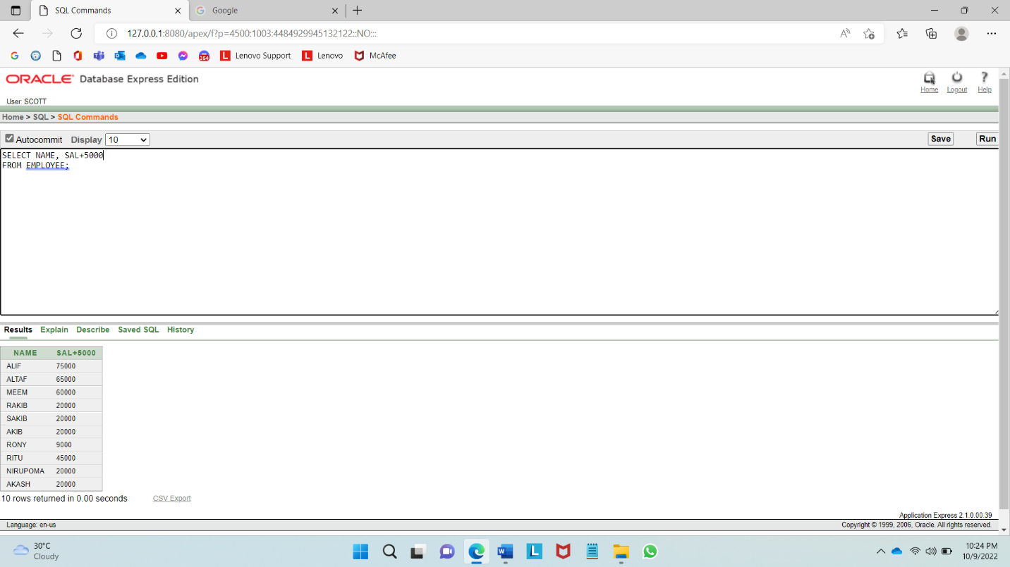

1. How to use arithmetic operator (maintaining precedence)?

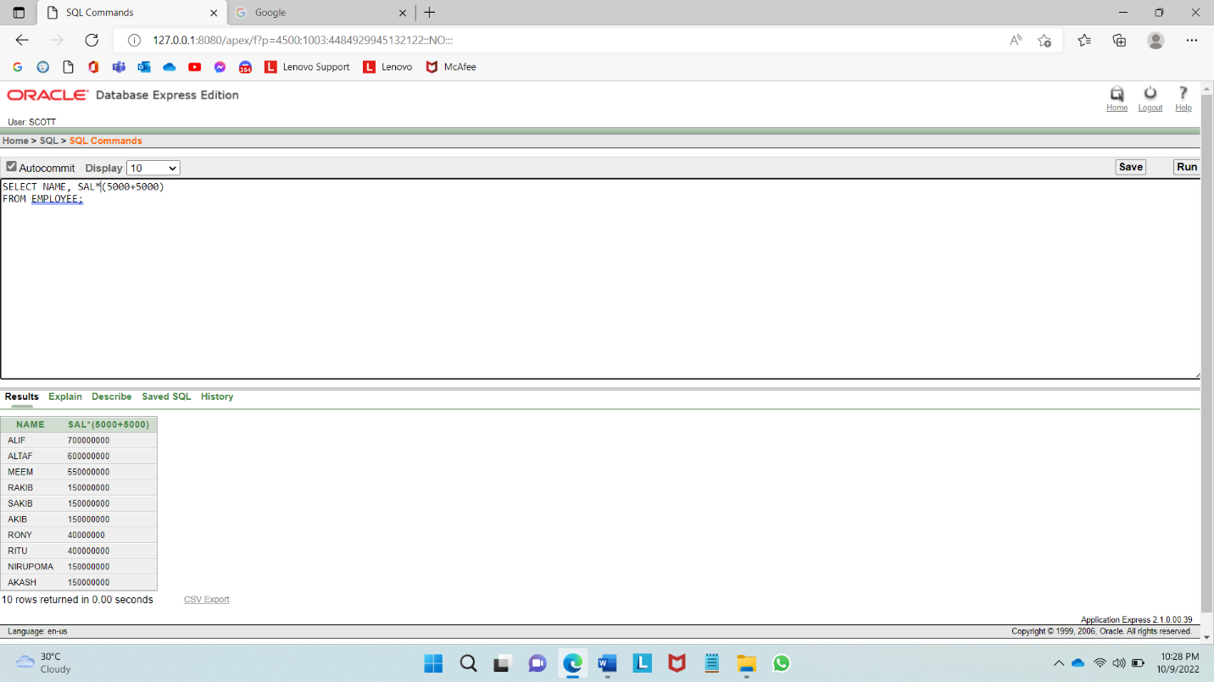

1. How to use column aliases?

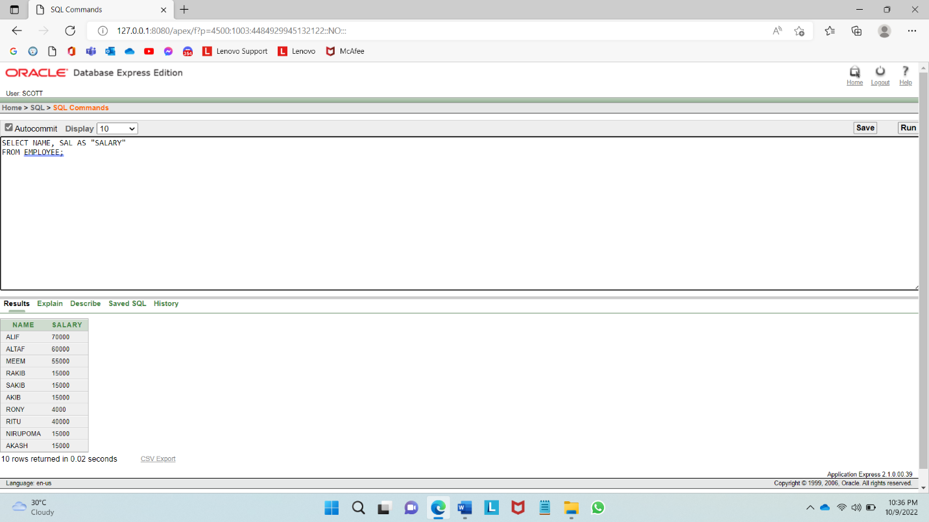

1. How to use concatenation operator?

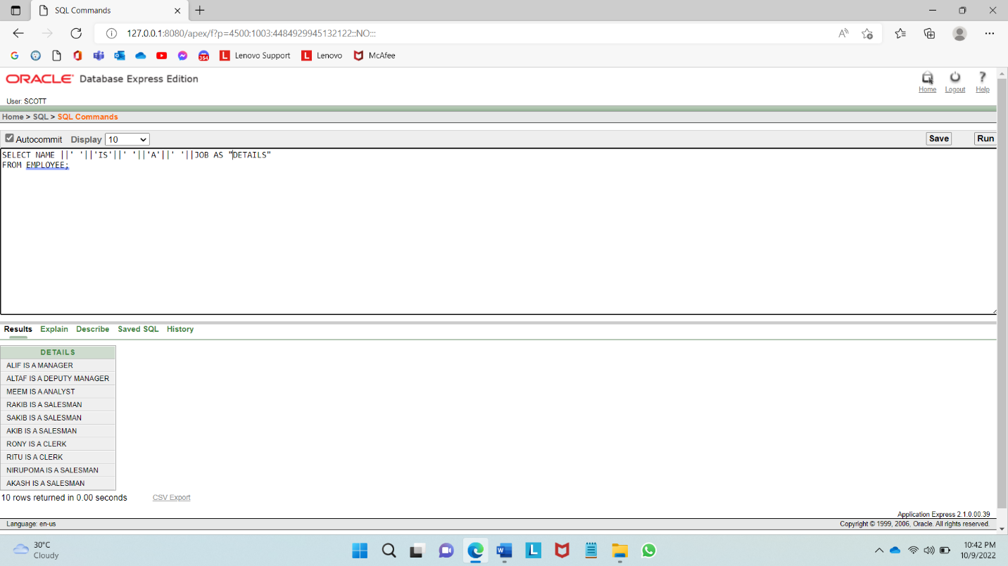

1. How to eliminate duplicate rows?

